**LINK SOURCE CODE:** [**https://binusianorg-my.sharepoint.com/personal/erwin_gunawan_binus_ac_id/_layouts/15/guestaccess.aspx?folderid=0405eb7118542465bb76978fbe2029ec0&authkey=AV4ut_-d9exUm_E5bccWjjI&e=Q1Cso3**](https://binusianorg-my.sharepoint.com/personal/erwin_gunawan_binus_ac_id/_layouts/15/guestaccess.aspx?folderid=0405eb7118542465bb76978fbe2029ec0&authkey=AV4ut_-d9exUm_E5bccWjjI&e=Q1Cso3)

**REGISTER PAGE:**

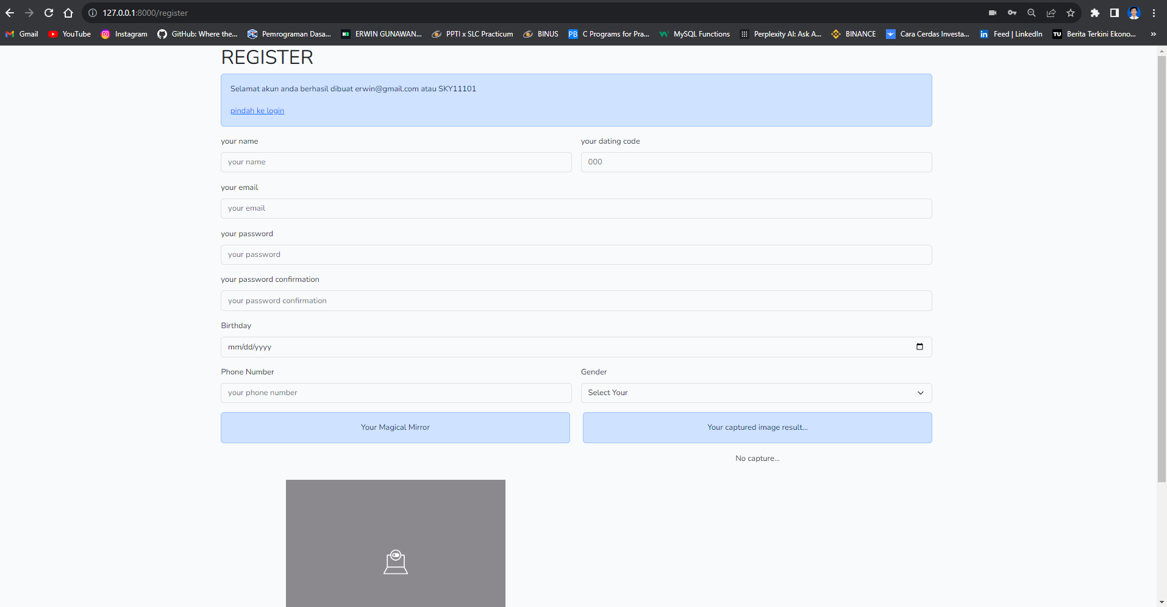

**LOGIN PAGE:**

**HOME / GAME PAGE :**

**Waiting Enemy AND PARTNER state…**

**Found Enemy But No wedding partner state…**

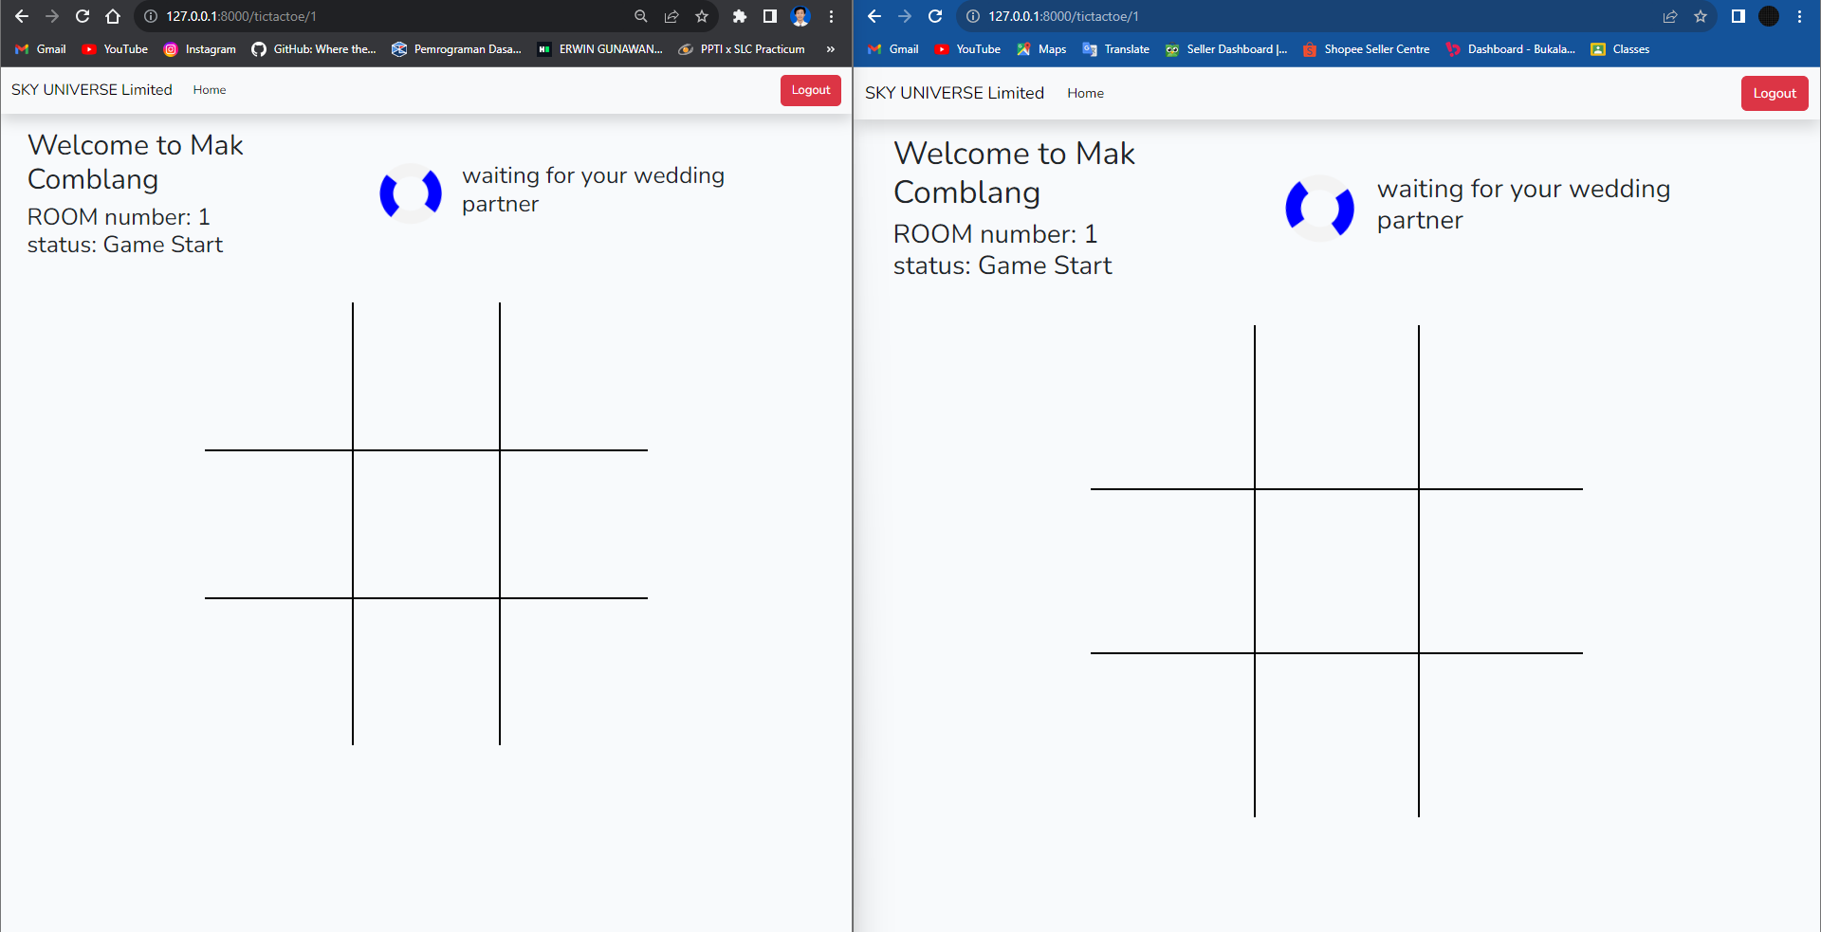

**Marketplace (Ketemu Jodoh) PAGE:**

**Marketplace (Filter) PAGE:**

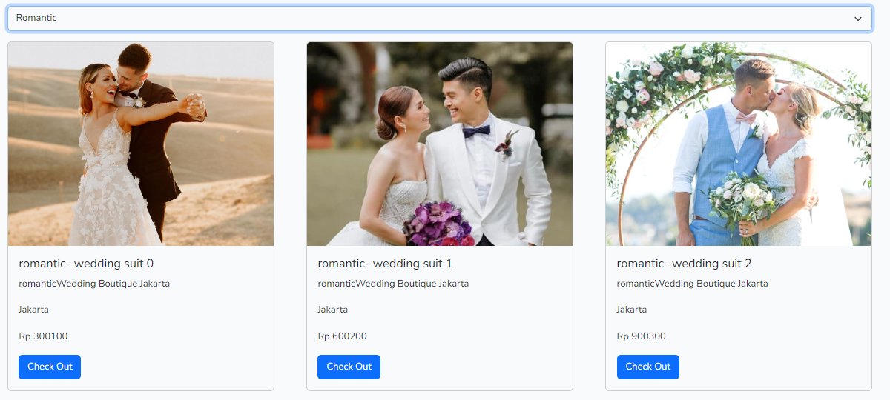

**

**Admin PAGE:**

